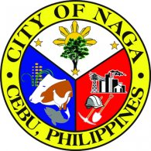

Republic of the Philippines
Province of @prov
@mun
@UTYPE HEALTH OFFICE
C E R T I F I C A T I O N
Permit No. |  |  | @refno
This is to certify that the results of water samples collected from @applicant at @address on @datefrom - @dateto, @year showed that the water supply have passed the requirement set by the Philippine National Standard for Drinking Water for physical, chemical, biological, bacteriological and radiological quality.
Recommending Approval:
@inspector
Sanitary Inspector
 |  |  |  | By Authority of Secretary of Health :
 |  |  |  | @healthofficer
 |  |  |  | @ltype Health Officer
Amt Fee: | @amount
OR No: | @orno
Date Issued: | @datepaid
@mun, @prov, Philippines

